EXPORT AND STORE NEXTMD LEGACY PORTAL PATIENT MESSAGES
Dear HealthPoint Patients,
As we shift to a new patient portal, we want to make sure you have access to your historical medical records and can export them. If you would like to export any of your records from the portal, please follow the below instructions prior to the upgrade to the new Portal. Once the new portal is active, the NextMD Portal will no longer be accessible.
Log into NextMD Patient Portal
  - URL: NextMD
  - Login with patient credentials
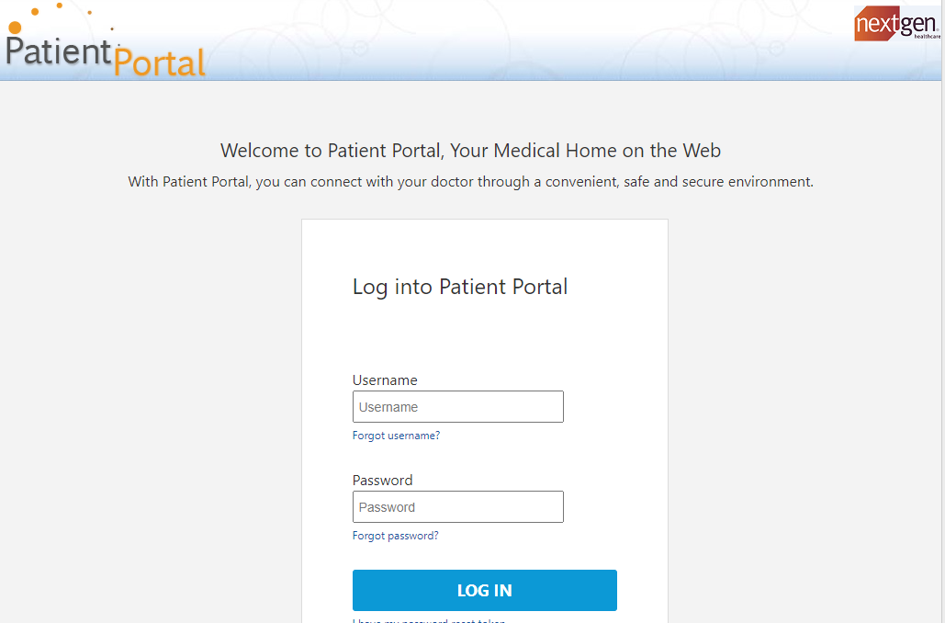

- Navigate to the Mail Tab
  - Select the “Export Messages” list item in the dropdown menu
  - Enter the filtering criteria that applies to content to be exported for historical records
  - When criteria is entered select “Download Messages”
  - Export to preferred file folder.
  - NOTE: The maximum downloads limits need to be adhered to to keep all messages. This step can be repeated for each Message Type.
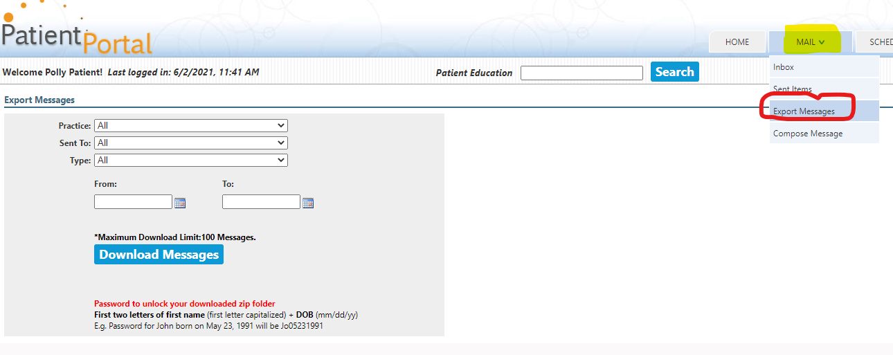
When completed, Log Out of NextMD Patient Portal, by clicking the blue active text in the top right corner.
Thank you!
HealthPoint

